Worship - October, 2007

Date | Sunday | Scriptures | Theme | Sermon
Oct. 7 | 19th Sunday after Pentecost  World Communion Sunday  Proper 22 C  Paraments are green | Luke 17:5-10 | Forgiveness and justice | Becoming a Beloved Community
Oct. 14 | 20th Sunday after Pentecost  green | Children’s Sabbath
Oct. 21 | 21st Sunday after Pentecost  green | Genesis 1 | Attributes of God | God of Grace and God of Glory
Oct. 28 | 22nd Sunday after Pentecost  Reformation Sunday  Paraments are red | Jeremiah 31:31-34 | What is new about the  New Covenant? | Write to the Heart

Music
Hymn of the Month - 617, I Come with Joy

Date October 7 Listen ↓
617 I Come with Joy Dove of Peace
616 Come, Sinners, to the Gospel Feast Hursley http://www.cyberhymnal.org/htm/c/o/comsinrs.htm
545 The Church’s One Foundation Aurelia http://www.cyberhymnal.org/htm/c/h/chofound.htm

Date October 14 Children’s Sabbath

Date October 21
617 I Come with Joy Dove of Peace
577 God of Grace and God of Glory Cwm Rhondda http://www.cyberhymnal.org/htm/g/o/godgrace.htm
89 Joyful, Joyful, We Adore Thee Hymn to Joy http://www.hymnsite.com/lyrics/umh089.sht

Date October 28
617 I Come with Joy Dove of Peace
500 Spirit of God, Descend upon My Heart morecambe http://www.hymnsite.com/lyrics/umh500.sht
110 A Mighty Fortress Is Our God Ein Feste Burg http://www.cyberhymnal.org/htm/m/i/mightyfo.htm

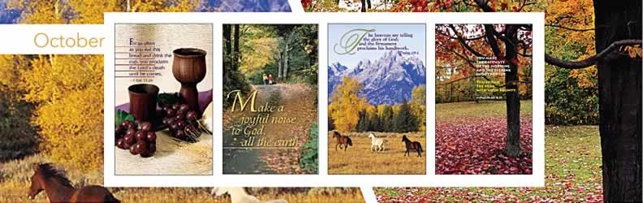

Sunday | 7 | 14 | 21 | 28
Liturgical Day | Nineteenth Sunday After Pentecost  (UM Kingdomtide) | Twentieth Sunday After Pentecost  (UM Kingdomtide) | Twenty-first Sunday After Pentecost  (UM Kingdomtide) | Twenty-second Sunday After Pentecost  (UM Kingdomtide)
Special Day | World Communion Sunday |  | Laity Sunday | Reformation Sunday  United Methodist Men’s Day  Disability Awareness Sunday
Lections Day | Lam. 1:1-6  Ps. 137 or UMH 852  2 Tim. 1:1-14  Luke 17:5-10 | Jer. 29:1, 4-7  Ps. 66:1-12 or UMH 790  2 Tim. 2:8-15  Luke 17:11-19 | Jer. 31:27-34  Ps. 119:97-104 or Ps. 19 or UMH 750  2 Tim. 3:14-4:5  Luke 18:1-8 | Joel 2:23-32  Ps. 65 or UMH 789  2 Tim. 4:6-8, 16-18  Luke 18:9-14
Suggested Colors | Green | Green | Green | Green

Sunday | Monday | Tuesday | Wednesday | Thursday | Friday | Saturday
 | 1 | 2 | 3 | 4  Shemini Atzeret | 5  Simchat Torah | 6
7  World Communion Sunday | 8  Thanksgiving Day (Canada)  Columbus Day observed | 9 | 10 | 11 | 12  Columbus Day | 13
14  Laity Sunday (ecumenical)  National Children's Day | 15 | 16  Boss's Day | 17 | 18 | 19 | 20
21  Laity Sunday (UM) | 22 | 23 | 24  United Nations Day | 25 | 26 | 27
28  Reformation Sunday  UM Men's Day  Disability Awareness Sunday (UM)  Daylight Saving Time ends | 29 | 30 | 31  Reformation Day  Halloween

< Previous | Next >

